**GitHub Installation Setup**

Link: [https://github.com/signup?source=login](https://github.com/signup?source=login" \o "https://github.com/signup?source=login)

* After opening it a page will be appeared as shown in below.
* The diggibyte email should be used for creating the Github account

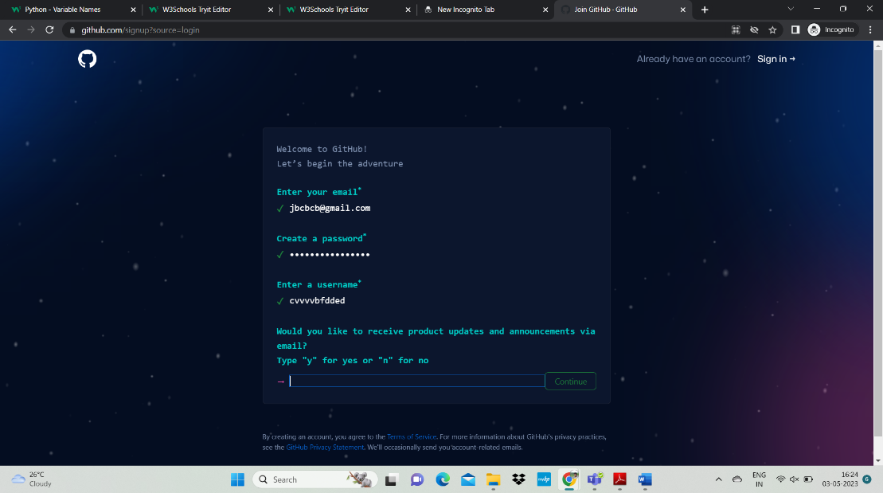

* After entering the details you need to select the identical things in the puzzle
* After selecting click on create account.
* OTP will be sent to the registered email enter the OTP and you will be directed to your account.

